UNIT 4 GRAMMAR KEY
UNIT 4 GRAMMAR

Narrative tenses
We use different past tenses to describe moments and periods of time in the past.
Past Simple
Form
The form of the Past Simple is the same for all persons.
He left at three o’clock.
They arrived three weeks ago.
She didn’t finish on time yesterday.
I didn’t visit my parents last weekend.
When did he finish the report?
What time did they leave?
Short answer
Did you enjoy the meal? Yes, we did./No, we didn’t.
Use
The Past Simple is used to express:
1 a finished action in the past.
We met in 2000.
John left two minutes ago.
2 actions that follow each other in a story.
Mary walked into the room and stopped. She listened carefully.
She heard a noise coming from behind the curtain and …
3 a past situation or habit.
When I was a child, we lived in a small house by the sea. Every day, I walked for miles on the beach with my dog.
This use is often expressed with used to.
We used to live in a small house …
I used to walk for miles …
Spelling of verb + -ed
1 Most regular verbs add -ed to the base form of the verb.
worked wanted helped washed
2 When the verb ends in -e, add -d.
liked used hated cared
3 If the verb has only one syllable, with one vowel + one consonant, double the consonant before adding -ed.
stopped planned robbed
But we write cooked, seated, and moaned because there are two vowels before the consonant.
4 The consonant is not doubled if it is -y or -w.
played showed
5 In most two-syllable verbs, the end consonant is doubled if the stress is on the second syllable.
pre’ferred ad’mitted
But we write ‘entered and ‘visited because the stress is on the first syllable.
6 Verbs that end in a consonant + -y change the -y to -ied.
carried hurried buried
But we write enjoyed, because it ends in a vowel + -y.
There are many common irregular verbs.
Past Simple and time expressions
Look at the time expressions that are common with the Past simple.
I met her ...
last night.
in 2001.
two days ago.
in summer.
yesterday morning.
when I was young.
Past Continuous
Form
was/were + verb + -ing
I was learning French. They were driving to Paris.
We weren’t waiting for a long time.
What were they doing? Where was he studying?
Short answer
Were you looking for me? Yes, I was./No, I wasn’t.
Were they waiting outside? Yes, they were./No, they weren’t.
Use
The Past Continuous is used:
1 to express activities in progress before, and probably after, a particular time in the past.
At seven o’clock this morning, I was having my breakfast.
You made a lot of noise last night. What were you doing?
2 for descriptions
It was a lovely day and the sun was shining. Jan looked beautiful. She was wearing a green cotton dress.
3 to express an interrupted past activity.
When the phone rang, I was having a shower.
While we were playing tennis, it started to rain.
4 to express an incomplete activity.
I was reading a book during the flight. (I didn’t finish it.)
Past Simple or Past Continuous?
1 Sometimes both tenses are possible. The Past Simple focuses on past actions as complete facts. The Past Continuous focuses on the duration of past activities, often describing being in the middle of them. Compare:
A I didn’t see you at the party last night.
B No. I stayed at home and watched the football.
A I phoned at 8.00, but you didn’t answer.
B Sorry, I was watching the football.
2 Questions in the Past Simple and Past Continuous refer to different time periods. The Past Continuous asks about activities that began before; the Past Simple asks about what happened after.
A What were you doing when the accident happened?
B I was shopping.
A What did you do when you saw the accident?
B I phoned the police.
used to
Used to expresses a habit or state in the past that is now finished.
I used to read comics when I was a kid. (but I don’t now)
Did you use to read comics when you were a child?
This town didn’t use to be a nice place to live, but then it changed.
Past Perfect
The Past Perfect refers to an action in the past that was completed before another action in the past.
Form
The form of the Past Perfect is the same for all persons.
Positive and negative
I/You/We'd/hadn't left when the post came.
Question
Where had you/she/they been before?
Short answer
Had he already left? Yes, he had./No, he hadn't.
Use
1 The Past Perfect is used to make clear that one action in the past happened before another action in the past.
When I got to my car, I saw that someone had broken into it.
I didn’t go to the cinema because I’d seen the film before.
2 The Past Simple tells a story in chronological order.
Sue met Pete at university. They got married. They were together for six years. They divorced last month.
The Past Perfect can be used to tell a story in a different order.
Sue and Pete divorced last month. They’d met at university, and had been together for six years.
3 Notice the difference between these sentences.
When I got to the party, Peter went home.
(= First I arrived, then Peter left.)
When I got to the party, Peter had gone home.
(= First Peter left, then I arrived.)
4 The Past Perfect Continuous refers to longer actions or repeated activities.
We were exhausted because we’d been driving all day.
I went to the doctor because I’d been having a lot of headaches.

Past tenses in the passive
Form
Past Simple passive: was/were + past participle
The museum was opened in 1987.
Past continuous passive: was/were being + past participle
The trees were being cut down.
Past Perfect passive: had been + past participle
The house had been redecorated.
Use
The uses are the same in the passive as in the active.
The bridge was built in 1876. (finished action in the past)
The bridge was being repaired when it collapsed. (interrupted past activity)
The letter didn’t arrive because it had been sent to my old address. (one action before another action in the past)

Match the picture numbers with the verbs in the box.
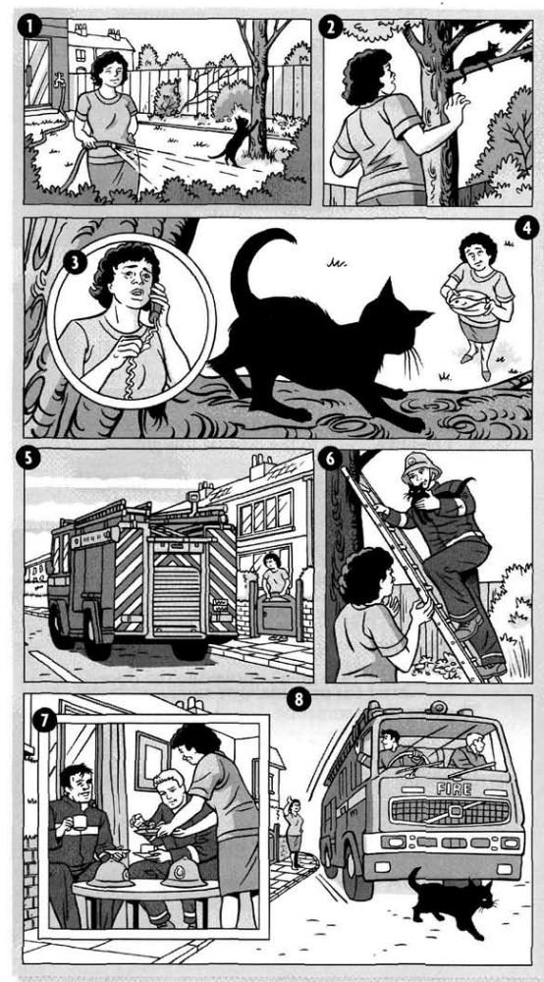 | PAST SIMPLE  _2_ ran up  _8_ killed  _5_ arrived  _6_ put up  _2_ called  _3_ rang  _6_ rescued  _8_ ran him over  _2_ couldn’t get down  _7_ invited them for tea  _4_ tried to tempt him down | PAST CONTINUOUS  _4_ was waiting  _1_ was watering the plants  _8_ were leaving  _1_ was playing  _7_ were having tea
Complete the story with the phrases in the box.
YESTERDAY EVENING, Mrs Taylor (1) was watering the plants in her garden, while her cat, Billy, (2) _WAS PLAYING_ near her. Suddenly, Billy (3) __RAN UP__ a tree. Mrs Taylor (4) __CALLED__ to Billy, but he (5) _COULDN’T GET DOWN__ , so she (6) _RANG_ the Fire Brigade. While she (7) __WAS WAITING_ for them to arrive, she (8) _TRIED TO TEMPT HIM_ with some fish. The Fire Brigade eventually (9) __ARRIVED_ , (10) ___PUT UP__ their ladder and (11) __RESCUED__ Billy. Mrs Taylor was so pleased that she (12) _INVITED THEM IN FOR TEA__. While they (13) __WERE HAVING TEA__ , they didn't see Billy go outside again, and ten minutes later as they
(14) __WERE LEAVING___ , they (15) ___RAN HIM OVER_ and unfortunately they (16) _KILLED___him.

Correct these false statements about the story.
1 The story happened last month.
The story didn't happen last month. It happened yesterday evening.
2 Mrs Taylor was cutting the grass.
SHE WASN’T CUTTING THE GRASS, SHE WAS WATERING THE PLANTS.
3 Billy was sleeping in the garden.
BILLY WASN’T SLEEPING IN THE GARDEN, HE WAS PLAYING.
4 Billy jumped over the wall.
BILLY DIDN’T JUMP OVER THE WALL, HE RAN UP A TREE.
5 Mrs Taylor rang the Police.
MRS.TAYLOR DIDN’T RING THE POLICE, SHE RANG THE FIRE BRIGADE.
6 The Fire Brigade used a rope to get Billy down.
THE FIRE BRIGADE DIDN’T USE A ROPE, THEY USED A LADDER.
Choose the correct form of the verb.
1 They fell/ were falling in love when they worked / were working in Rome.
2 She read/ was reading quietly in her room when suddenly the lights went / were going out and she heard/ was hearing a scream.
3 He stood / was standing up, walked / was walking across the room, and closed / was closing the window.
4 A young woman walked / was walking into the office. She carried / was carrying a baby.
5 Didn't you meet / Weren't you meeting your wife while you lived/ were living in Italy?
6 I saw / was seeing you in the park yesterday. You sat/ were sitting with your arm round Tom.
7 As soon as I walked / was walking into the room, she handed/ was handing me the letter.
8 His father was really angry with him because he listened/ was listening to music while he did / was doing his homework.
9 Why didn't they visit/ weren't they visiting me when they stayed/ were staying in London? 10 What did you write / were you writing when your computer crashed/ was crashing?

Complete the text with the correct form of the verbs, Past Simple or Past Continuous.
Last February, I (1) decided (decide) to go on holiday to Florida. The day I (2) _LEFT__ (leave) England it (3) _WAS RAINING___ (rain), but when I (4) _LANDED_ (land) in Florida, the sun (5) __WAS SHINING_ (shine) and a lovely, warm breeze (6) __WAS BLOWING__ (blow) from the sea. I (7) __TOOK__ (take) a taxi to my hotel. As I (8) __WAS CHECKING IN___ (check in), someone (9) __TAPPED__ (tap) me on the shoulder. I (10) _COULDN’T_ (can not) believe my eyes! It was my old girlfriend. She (11) _WAS STAYING__ (stay) at the same hotel. The next day, we (12) __WENT__ (go) snorkelling and (13) __SAW___ (see) hundreds of beautiful fish. It (14) __WAS GETTING_ (get) dark when we (15) __RETURNED_ (return) to our hotel after a wonderful day. We (16) __SPENT_ (spend) the rest of the week together. It was very romantic. We (17) __FELT__ (feel) very sad when the holiday (18) __ENDED__(end).
Choose the correct tense in the story.
It was ten o'clock in the evening. Peter (1) sat/ had sat down on his sofa and thought about the day. What a busy day it (2) was / had been. This was his first night in his own flat. He (3) lived/had lived his entire life in the family home, and now for the first time, he (4) was / had been on his own.
He sat surrounded by boxes that they (5) didn't manage / hadn't managed to unpack during the day. It (6) took/ had taken months to get all his things together. His mother (7) was / had been very generous, buying him things like towels and mugs.
He (8) went / had gone into the kitchen and (9) made / had made a sandwich. He suddenly (10) felt / had felt very tired and yawned. No wonder he (11) was / had been tired!
He (12) was / had been up since six o'clock in the morning. He (13) decided/ had decided to eat his sandwich and go to bed. But he didn't get there...

Complete the sentences with the words in brackets. Use the Past Perfect.
1 I was broke because I had spent all my money on clothes.
(spend/money/ clothes)
2 Jane was furious because she HAD OVERSLEPT AND (HAD) MISSED THE BUS.
(oversleep and miss the bus)
3 Mary was very disappointed with her son. He HADN’T STUDIED ENOUGH AND HAD FAILED HIS EXAMS. (not study enough and fail exams)
4 Before his accident, Peter HAD BEEN THE BEST PLAYER IN THE TEAM.
(be/best player / team)
5 I was very nervous as I waited in the departure lounge. I HAD NEVER FLOWN BEFORE.
(never/fly/before)
6 Jack wanted a new challenge in his work. He HE HAD DONE THE SAME JOB FOR TEN YEARS. (do/same job / ten years)
7 I didn't know his name, but the face was familiar. I was sure I HAD SEEN HIM SOMEWHERE BEFORE. (see / somewhere before)
8 When I got home, I was starving. I HADN’T HAD ANYTHING TO EAT ALL DAY.
(not have anything to eat all day)
Rewrite the sentences using the passive.
1 Somebody broke my glasses. My glasses were broken.
2 Nobody asked him to come. He wasn't asked to come.
3 Somebody left the lights on. The lights WERE LEFT ON.
4 Somebody told me about it yesterday. I WAS TOLD ABOUT IT.
5 Nobody invited her to the party. She WASN’T INVITED.
6 Somebody took us to the hospital. We WERE TAKEN TO THE HOSPITAL.
7 Nobody gave them any information. They WEREN’T GIVEN ANY INFORMATION.
8 Did anybody find the missing child? Was THE MISSING CHILD FOUND?
9 Did anything disturb you in the night? Were YOU DISTURBED IN THE NIGHT?
Complete the sentences with was, were, did, or had.
1 The flight _____WAS___delayed because of bad weather.
2 ___DID___you do much sightseeing when you visited Paris?
3 They ____WERE___leaving for the train station when I last saw them.
4 I ___HAD___forgotten to set my alarm clock, so I was late for work.
5 ___WAS___it raining when you left the cinema?
6 The workers ____WERE__told last night that the factory was closing.
7 The police found the money which ___HAD______been stolen from the bank.
8 The fire _____WAS___caused by an electrical problem.
9 She was surprised he knew her name. She ___HAD___never met him before.
10 How many times __WERE____your passports checked before you got on the plane?

